From http://www10.mcadcafe.com/nbc/articles/view_article.php?articleid=500058

MCAD Industry View - A March 2008 Update

by Dr. Russ Henke and Dr. Jack Horgan
Henke Associates

In the first MCAD Industry Commentary published May 2003 in MCADCafé.com, then-recent yearly and quarterly financial performances of a selected group of public Mechanical Computer Aided Design (MCAD) companies were analyzed and compared. Expectations of future financial performances of these same MCAD entities were documented. The May 2003 MCAD Commentary was followed by eighteen quarterly updates in MCADCafé.com, one for each subsequent calendar quarter. URL's on all past articles are available. The entities covered were ANSYS, Autodesk, Dassault Systèmes, UGS PLM, ESI Group, Moldflow, MSC.Software, PTC and Tecnomatix.
As a result of the acquisition of Tecnomatix by UGS that closed April 1, 2005, Tecnomatix was eliminated from coverage thereafter as a separate entity.
On May 07, 2007 UGS announced the close of its acquisition by Siemens AG effective May 4, 2007. As a result, the business will go to market as UGS PLM Software, a global division of the Siemens Automation and Drives (A&D) Group. Over the years UGS has bounced back and forth between being a public company and a private company under different ownership. Although not required to do so, UGS has reported on its financial results even when privately held. For the first quarter of 2007 there was only a terse statement from Tony Affuso, chairman and CEO of UGS PLM Software, “We had a very strong quarter in Q1, coming in near 11 percent on total revenue growth and 16 percent on software license growth.” This translates to about $300 million. According to a company spokesperson, UGS will no longer report results separately from Siemens. This is a very common practice with large corporations. In the first quarter of this year the A&D Group generated £3.9 billion of the £20.2 billion total Siemens revenue. We can expect very little insight into UGS performance from public Siemens’ reports going forward.
Accordingly, this nineteenth article in the sequel recounts the financial performances of the remaining group-of-seven (G7) MCAD/PLM entities for the nominal fourth quarter of 2007.
In this issue, recent MCAD news highlights are listed, followed by a group summary of revenue and earnings of the covered MCAD entities for Q4 2007, then company by company quarterly details, then vendor stock performances, then company by company yearly details, then future revenue forecasts by vendor.
Recent MCAD & PLM News Highlights
On January 15, 2008 Autodesk announced that it had completed the acquisition of Robobat, a privately-held company based in Grenoble, France, for approximately $42.5 million in USD cash, subject to a working capital adjustment. On November 15, 2007, Autodesk had announced an agreement to acquire Robobat. The Grenoble company provides software for structural engineering analysis, design, and steel and concrete detailing.
On February 19, 2008 Autodesk announced that it had signed a definitive agreement to acquire Kynogon SA, the privately held maker of Kynapse artificial intelligence middleware. Terms of the transaction were not disclosed. Kynapse is said to have been used to develop more than 65 AAA game titles, including Alone in the Dark 5, Crackdown, Fable 2 and The Lord of the Rings Online: Shadows of Angmar . Kynapse gives characters spatial awareness, enabling them to realistically navigate digital environments.
On January 14, 2008 MSC.Software expanded its thermal solution portfolio through its acquisition of Arizona-based Network Analysis, Inc. (NAI), a vendor of thermal simulation software and the developers of the SINDA/G(TM) thermal modeling software.
On January 23, 2008, Moldflow announced that more than 30 companies licensed Moldflow Plastics Insight - Enterprise Edition™ (MPI-e™) during its recent fiscal quarter ended December 31, 2007. This brings the total number of companies that have licensed MPI-e in just its first year of availability to 100.
On January 24, 2008 Dassault Systèmes announced PLM 2.0 and its new V6 platform. PLM 2.0 - PLM online for all - is said to be a 3D online environment for everybody to experience products virtually where all user interactions generate Intellectual Property (IP). V6 is DS's next generation platform for PLM 2.0.
On February 27, 2008, PTC announced the availability of CADDS 5 15.0, the newest release of its specialized CAD/CAM solution for shipbuilding. CADDS 5 and Optegra provide the power and performance needed to help large, dispersed teams create massive, highly complex assemblies within stringent schedules.
February 11, 2008 ESI Group announced the release of the new version of its PAM-CEM Solutions software package. This product is aimed at performing realistic and predictive ElectroMagnetic Compatibility (EMC) simulations in the transportation industry, in Aeronautics and Defense, in Telecommunications and in Electronics.
On February 25, 2008 ANSYS announced that it had been included on the Forbes Fast 15 list, a first-ever formal compilation by Forbes magazine of attractive companies with potential to become rapidly growing technology businesses in the future. ANSYS was the only engineering software provider to make the list.
On March 3, 2008 ANSYS announced that it had been listed among top performers on the 2007 Shareholder Scoreboard compiled by The Wall Street Journal. The Scoreboard is the newspaper's annual ranking of 1,000 companies in 75 industries, based on their stock performance over the past year as well as over the past 3-year, 5-year and 10-year periods. ANSYS was ranked #9 on the best performers' 10-year list, with a 36.8% average annual return for a decade. In addition, ANSYS was ranked #1 in the Software Industry Group with a 1-year return of 90.7%, as well as #14 on the Scoreboard's Honor Roll, a compilation of companies that earned straight-A ratings, ranked on five-year average compound annual total returns through year-end 2007.
As readers know, the MCAD software industry is dependent heavily on robust manufacturing activity. On March 01, 2008, The Chicago Tribune reported that the Chicago purchasing managers index, a closely followed measure of manufacturing activity, dropped in February to its lowest reading since the recession year of 2001. Meanwhile, weakening demand and plunging employment offered a clear signal that the industrial sector is in retreat. Instead of dropping from January's lackluster reading of 51.5 to 49.5 in February, as economists had predicted, the index unexpectedly plunged seven full points, to 44.5, its lowest level since December 2001. Economist Ryan Sweet of Moody's Economy.com noted that "a below-50 level in orders and uncertainty about the economic outlook have led manufacturers to hit the brakes." He added that this "report underscores the fact that with consumers turning wary and the impact from the collapse of the housing sector still spreading, the manufacturing sector is clearly struggling."
As we sink deeper into W’s second recession, here is another economic tidbit. Capping a unremitting rise in the last seven years, oil prices hit a record high during the day on March 3, 2008, according to a report March 4, 2008 in the New York Times. The day’s highest trading price, $103.95 a barrel on the New York Mercantile Exchange, broke the record set in April 1980 during the second oil shock. That price, $39.50 a barrel, equals $103.76 today, when adjusted for inflation. The trend is expected to continue, especially after FED Chairman Ben Bernanke signaled in late February 2008 that he was ready to cut interest rates still further to try to bolster sagging US economic growth, despite relentlessly rising consumer prices. Sales of cars and trucks in the United States fell 10% in February 2008. Americans were paying an average of $3.165 for a gallon of regular gas as of March 3, 2008, 69.8 cents more than a year ago, according to the AAA. In CA it’s more like $3.50 now. Analysts say that a US average for regular of $4 a gallon is possible within months. By the way, oil was about $25 a barrel when W took office in 2001.
Closing quote from Nobel Prize-winning economist Joseph Stiglitz at a congressional hearing on February 28, 2008: “Because the Bush administration actually cut taxes as we went into the current Iraq war, when we were already running huge deficits, this war has, effectively, been entirely financed by deficits. The national debt has increased by some $2.5 trillion since the beginning of the Iraq war, and of this, almost $1 trillion is due directly to the Iraq war itself ... By 2017, we estimate that the national debt will have increased, just because of the war, by some $2 trillion.”
MCAD Vendors' Financial Performances in Q4 2007
As a group, the G7 MCAD vendors generated combined revenues of $1.584 billion, an impressive increase of over 17% from the $1.351 billion in the fourth quarter of 2006, and a healthy boost of over 13% from the $1.4 billion in the just prior quarter. See Table 1 below. All of the G7 firms delivered year-over-year revenue growth. ANSYS was the percentage revenue growth leader at 30%. Autodesk and Moldflow were next at 20% and 19%, respectively. Dassault and ESI Group also had double digit growth.
On a sequential quarterly basis, PTC and ESI Group were the only companies to suffer declining revenues. In the traditionally strong fourth quarter, Dassault, Moldflow and MSC provided sequential growth in excess of 20%, followed by ANSYS at 18%.
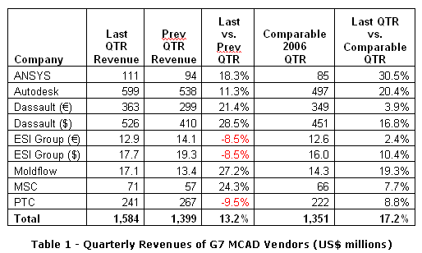
Figure 1 below provides a bar graph showing the revenue trend for each of the covered vendors, for the quarterly periods mentioned in Table 1.
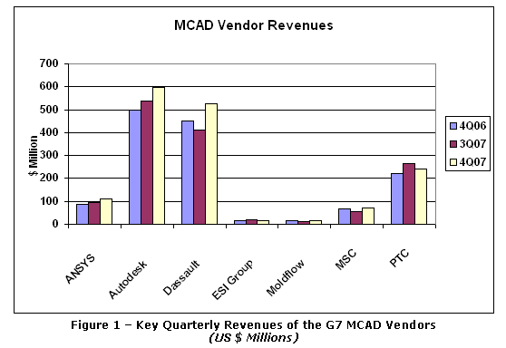
For the quarter, Figure 2 below clearly shows that Autodesk remained the market share leader at 39% of the G7, followed in order by Dassault Systemes and PTC at 33% and 15%, respectively. The others had low single digit share with ANSYS creeping up, now number four at 7%.
(As always, it's useful to point out that unlike the other vendors in this report, Autodesk earns a major portion of its revenue outside of the pure MCAD space. Autodesk does not break out its mechanical contribution. Also, both Autodesk and Dassault Systemes sell mostly through third parties, while PTC sells mostly direct. The figure of course excludes UGS, which did not report revenue for the quarter separately from Siemens AG).
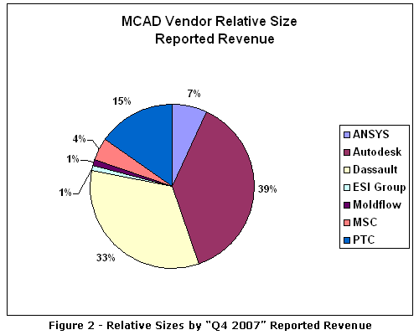
While Q4 2007 G7 earnings growth year-over-year was not nearly as spectacular as percentage revenue growth, the combined Q4 2007 earnings of the G7 was nevertheless $253 million, up 6.3% from the $238 million in the fourth quarter of 2006. Q4 2007 G7 earnings did recover nicely from the much lower figure in the just prior quarter, up 42% from $178 million in Q3 2007. See Table 2.
The six out of the seven MCAD vendors that reported earnings all had net income. On a year-over-year basis, ANSYS had the largest percentage earnings gain at 148%, with Moldflow a strong second at 111%. MSC.Software and PTC had declining earnings at minus 8.9% and minus 5%, respectively. On a sequential quarterly basis, all reporting firms had improved earnings except PTC, whose earnings declined 67%. Moldflow and Dassault were the sequential quarterly percentage gain leaders at 190% and 161%, respectively. ANSYS was a strong third at 57%.
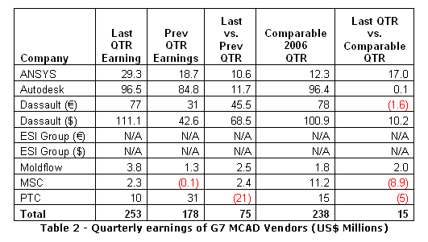

On February 21, 2008 ANSYS, Inc. reported financial results for its fourth quarter and calendar year 2007, the periods ended December 31, 2007. Total revenue for the fourth quarter was $111 million, a whopping increase of 30.5% from the $85.2 million in the fourth quarter of 2006, and a significant increase of 18.3% from the $94 million in the just prior quarter. The $111 million in revenue for Q4 was at the top of the $99 million to $111 million given as guidance last quarter. Software license revenue was $75.6 million, or 68% of total revenue. This was a remarkable 42% increase year-over-year, and a 24% increase over the pervious quarter. Maintenance and services revenue was $36.7 million, or 32% of total revenue. This was a year-over-year increase of 11% and a sequential increase of 8.3%. Maintenance was up over 20% year-over-year while services revenue was down.
In the fourth quarter, there were five customer deals in the seven figure range. Typically there would be one such mega-deal.
Revenue from North America increased 17% year-over-year, from Europe +27%, and from General International +26% (which included a 19% increase from Japan). European revenue had a favorable currency conversion impact of $3.2 million. Direct revenue was 70% of total revenue and indirect 30%. Software leases accounted for 27% of the business.
Net income for the quarter was $29.2 million, an increase of 139% from the $12.2 million in the fourth quarter of last year, and a 57% increase from the $18.6 million in the prior quarter. There was also a $3 million tax benefit in the quarter.
ANSYS President & CEO Jim Cashman, said, “We are pleased to report the strongest quarterly and annual performance in our Company's history, including our first quarter of over $100 million in revenue. With solid contributions from all aspects of our business, we exceeded our growth and profitability plans for both the fourth quarter and for the year.”
He added, “We began 2007 with strong business and customer momentum and are pleased that we were able to leverage that momentum throughout the year to close out the fourth quarter with double-digit growth in all major geographies.”

On February 26, 2008 Autodesk Inc reported financial results for the fourth quarter and the year, the periods ended December 31, 2007. Total revenue for the quarter was $599 million, a vigorous increase of 20% from the $497 million in the year ago quarter, and an increase of 11% form the $538 million in the just previous quarter. License revenue of $446 million, accounting for 74% of total revenue, was an increase of 19% year-over-year, and an almost 13% increase sequentially. Maintenance revenue was $153 million, an increase of 25% year-over-year and a 7.4% increase over the prior quarter.
The Platform segment, which accounts for about 44% of revenue, includes AutoCAD and AutoCAD LT products that service multiple markets. Other segments are AEC (previously two segments: Building and Infrastructure) and Media/Entertainment (previously named Discreet). The Manufacturing segment (which includes the Inventor product lines) accounted for 20.5% of total revenue and grew 25.5% year-over-year and 20.6% from the prior quarter. A “guesstimate” of MCAD revenue would be about $230 million for the quarter.
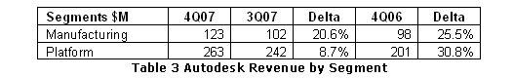
Design segment revenues increased 21.6% over the fourth quarter of fiscal 2007 to $523 million, accounting for 87% of total revenue. Combined revenue from the Company's model-based 3D products -- Inventor, Revit, Civil 3D and NavisWorks software -- increased 21% over the fourth quarter of fiscal 2007 to $146 million. Autodesk shipped approximately 21,000 commercial seats of Revit and NavisWorks, over 17,000 commercial seats of Inventor and over 7,500 commercial seats of Civil 3D.

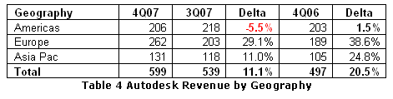
Compared to the fourth quarter of 2007, revenue in EMEA increased 38% to $262 million. Revenue in Asia Pacific increased 24% year-over-year to $131 million. Revenue from the emerging economies in Asia Pacific, EMEA and Latin America increased 52%, and were 19% of total revenue. Strong growth in these international geographies was offset by miniscule Q4 2007 revenue growth in the Americas of only 2% over the fourth quarter of 2006. See Table 4.
Carl Bass, Autodesk president and CEO, said, "Autodesk delivered another quarter of solid revenue results, capping another record year. Our results demonstrate the strength and stability our business model provides. Because our geographic balance and customer and industry diversification help insulate Autodesk from changes in any one particular market, we remain optimistic about the coming year."

On February 13, 2008 Dassault Systemes reported financial results for the fourth quarter and calendar year ended December 31, 2007. Total revenue was ï¿½363 million, an increase of only 4% from the ï¿½349 million in the fourth quarter of 2006, but an increase of over 21% from the ï¿½299 million in the prior quarter. In US$, software revenue was $447 million or 85% of total revenue, an increase of 21% year-over-year and an increase of 27.5% sequentially. New license revenue was 43% of software revenue, while recurring software revenue was 57%. (Dassault Systemes, a French company, reports its financial results in euros but provides average conversion factors to dollars for each quarter and year. These factors were used to calculate US dollar numbers. Revenue growth in terms of constant currency non_GAAP was 12%, below the 14-15% range given as guidance last quarter).
Revenue from North America at $154 million accounted for 29% of total revenue. This was an increase of nearly 10% year-over-year and 17% sequentially. Revenue from Europe was $263 million accounting for 50% of total revenue. This was an increase of 19% year-over-year and 47% sequentially. Revenue from Asia was $110 million, accounting for 21% of total revenue. This was an increase of 21% year-over-year and an increase of 11% from the prior quarter.
The Enovia brand which includes Enovia, MatrixOne and SmarTeam generated $73 million in the quarter, or 14% of total revenue. This was a 26% increase year-over-year, but it was almost a 7% decrease sequentially. Note that MatrixOne was acquired in May 2006 for $410 million. Dassault has now combined SolidWorks and CosmosWorks into Mainstream 3D. This category generated $97 million, accounting for 18.5% of total revenue. CAD generated $212 million or 40% of total revenue. See Table 5.
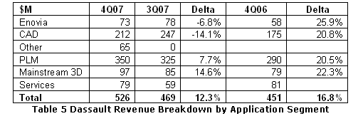
In the quarter 11,314 seats of CATIA were sold, up 2% year-over-year, and 13,861 seats of SolidWorks, up 12%. In the year 36,202 seats of CATIA were sold, essentially the same as 2006; and 48,899 seats of SolidWorks were sold, up 13%.
Net income for the quarter was $111 million, an increase of 10% from the $101 million in the same quarter a year ago, and an increase of 168% from the $43 million in the just previous quarter.
Thibault de Tersant, Senior Executive Vice President and CFO of Dassault, said, “The fourth quarter is always our largest quarter, representing about one-third of our total revenues for the year. To give you a sense of how much is accomplished during this quarter, on a sequential basis our revenue increased 23% and our net earnings more than doubled.”
He added, “2007 has been a year of major sales transformation and the fourth quarter was particularly important as we prepared to take responsibility for two large markets in our PLM indirect channel during the 2008 first quarter - specifically Germany and Japan. Secondly, we have also been preparing the introduction of our new, next generation PLM platform.”

On December 11, 2007 ESI Group r eported financial results for its third quarter, the period ended October 31, 2007. Total revenue was 12.9 million euros, a 2.4% increase over the 12.6 million euros in the same period a year ago, but an 8.5% decrease from the 14.1 million euros in the previous quarter.
Organic growth by volume was +5.6% compared to the third quarter of the previous financial year. The acceleration in growth recorded by Services associated with high value-added projects has been reaffirmed, with Services sales jumping +28.9% by volume to 3.7 million euros.
License sales totaled 9.2 million euros. This almost stable sales figure in volume terms should be put into perspective, as this activity is highly seasonal and that the third quarter of last year saw substantial growth of +14.6%, thus weighing on the comparison between Q3-06 and Q3-07.
Alain de Rouvray, ESI Group's Chairman and CEO, concluded, “Activity over our third quarter illustrates the confirmation of the trend noted over the first half of the year, i.e. a strengthening of Services activity essentially associated with high value-added projects. This improvement lays witness to ESI Group's ability to implement, amongst OEMs, physics based realistic digital simulation processes in an industrial context. The seasonality of our sales over this fiscal year should further increase, with a substantial proportion of our License activity recorded during our final quarter.”

On February 7, 2008 Moldflow Corporation reported results for its second quarter of fiscal 2008. Total revenue for the quarter was $17 million, an increase of 19% from the $14.3 million in the same quarter a year earlier, and a 27% increase from the $13.45 million in the previous quarter. Product revenue was $8.9 million, accounting for 52% of revenue. This was an increase of 16.7% year-over-year, and an increase of 53% sequentially. Services revenue was $8.2 million, accounting for 48% of total. This was an increase of 22.4% year-over-year, and a 7.4% increase sequentially.
Moldflow disposed of its Manufacturing Solutions business division on June 30, 2007; therefore, results from all prior periods have been reclassified to solely reflect the Company's continuing operations.
Net income for the quarter was $3.8 million, an increase of 11% from the $1.8 million in the year ago quarter, and a 190% increase from the $1.3 million in the prior quarter.
Roland Thomas, Moldflow Corporation's president and CEO, said, “The results of our second quarter show the continued progress we are making towards our corporate goals for fiscal 2008. In fact, our first half has delivered strong results which are at the high end of our expectations for this point in our fiscal year, and are trending towards the higher end of our stated guidance range for the 2008 fiscal year.”

On February 21, 2008 MSC.Software reported financial results for the fourth quarter and the year, the periods ended December 31, 2007. Total revenue for the quarter was $71 million, an increase of 7.7% from the $66 million in the fourth quarter of 2006 and a 24% increase from the low $57.2 million in the third quarter of 2007. Software revenue was $28.8 million, or 41% of total revenue. This was an increase of 3.3% year-over-year, and a 45% increase sequentially. Maintenance revenue was $33.3 million, or 47% of total revenue. This was an increase of 13% year-over-year, and an increase of 5.1% sequentially. Services revenue was $9 million, or 13% of total revenue, an increase of 3.2% year-over-year, and a 58% increase sequentially.
The Enterprise Simulation product category represented $7.7 million, or 27% of total software revenue versus 13% in Q4 last year.
There were only 108 bookings over $100,000 in the quarter compared to 123 in 4Q06. But the average transaction size was $350K in the quarter versus $256K in 4Q06.

Q4 revenue in North America accounted for 31% of total revenue, revenue in EMEA for 38% of total revenue, and revenue from Asia Pacific for 32%.
Net income for the fourth quarter was $2.3 million, compared to net income of $11.2 million in the year ago quarter and a net loss of $122K in the previous quarter.
Bill Weyand, CEO and Chairman of MSC.Software, said, "We believe that MSC's solid performance in the fourth quarter, particularly in the Americas, is a positive sign indicating that we are in the final stages of completing our company transition. In the fourth quarter we saw strength in both our engineering tools and our enterprise solutions product categories as well as in our key industry verticals of aerospace and automotive."
Weyland continued, "We believe that MSC has the key business drivers for success in 2008. Our innovative Simulation Enterprise and MD product line introductions should continue to provide us with a first mover advantage in the simulation software marketplace. Further, as we launch a new product cycle with the R3 versions of our enterprise simulation products, we expect to see increased customer acceptance and transaction activity.”

On January 23, 2008 PTC reported financial results for the first quarter of its fiscal 2008, the period ended December 29, 2007. Total revenue for the quarter was $241 million, an increase of almost 9% from the $221 million in the same quarter a year ago, but a 9.5% drop from the $267 million in the just prior quarter. The $241 million was slightly above the $230 to $240 million range given as guidance last quarter. License revenue was $67 million, accounting for only 28% of total revenue. While this was up almost 1% year-over-year, it was down 30% sequentially. Maintenance revenue was $114 million, accounting for 47% of total revenue. This was an increase of 13% year-over-year and an increase of 7.4% sequentially. Service revenue was $60 million or 25% of total revenue. This was an increase of 10.4% year-over-year, but a decrease of almost 7% sequentially. Reseller revenue was $60 million or almost 25% of total revenue. This was an increase of 26% year-over-year, and an increase of 16% sequentially.
In the quarter PTC sold 5,450 seats of Pro/Engineer and 41,900 seats of Windchill. Cumulative seats of Pro/Engineer reached 368,300 and of Windchill 533,400.
North American revenue was $84.5 million, accounting for 45% of total; European revenue was also $102 million, accounting for 55% of total revenue; and Asia Pacific revenue was $55 million, accounting for 30% of total revenue.
Year-over-year quarterly revenue growth of 23% in Europe, 7% in the Pacific Rim, and 3% in Japan, was partially offset by a 2% decline in North America. On a sequential basis, North America was down 17%, Europe was flat and Asia Pacific region was down 12%.
Net income for the quarter was $9.9 million, down 35% from the $15.1 million in the corresponding quarter last year, and down 67% from $30.6 million in the previous quarter.
C. Richard Harrison, president and chief executive officer, said, “We performed well in the first quarter. Our focus on delivering significant operating margin improvement in 2008 has begun to pay off. We delivered an 18.2% non-GAAP operating margin in the first quarter, a 330 basis point improvement from the same period last year. Our continued efforts to evolve our distribution and services models, our globalization strategy, and the immediate non-GAAP operating margin accretion provided by CoCreate contributed to this improvement. In addition, we continue to deliver revenue growth that is higher than market growth rates."
On December 3, 2007 PTC announced it had completed its acquisition of CoCreate Software GmbH, a provider of product development solutions, for approximately $250 million net of cash acquired and excluding transaction fees. CoCreate, based in Sindelfingen, Germany, has 280 employees and more than 5,000 customers globally including Agilent, Canon, Molex, Fujitsu, HP, Liebherr, Matsushita Electric, NEC, Olympus, Phoenix Contact and Seiko Epson. PTC financed the acquisition and related expenses with a combination of $50 million of cash and $220 million of debt from its existing revolving credit facility. PTC expects to repay the loan within two years. The transaction value represents approximately 3.1 times CoCreate's total revenue, 4.6 times its maintenance revenue, and 7.4 times its non-GAAP operating margins, based on trailing twelve-month data.
PTC's GAAP and non-GAAP results for the first quarter of fiscal 2008 include expenses of $3.2 million associated with its restatement of the third quarter of 2007 and prior financial results announced and completed during the quarter
MCAD Vendor Stock Performances
The combined stock prices of the selected MCAD vendors grew by almost 22% in absolute dollars from the same period last year, and by 21% in average price. This compares to an increase of only 6.6% for the major stock indexes year-over-year (and a decrease of 3.4% sequentially, presaging the then-upcoming US economic recession).
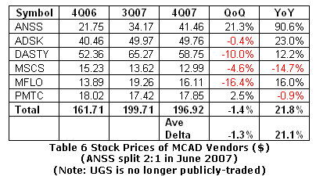
ANSYS was the percentage year-over-year growth leader at 91%, followed by Autodesk at 23% and Moldflow at 16%. MSC.Software was the lone decliner at negative 14.7%. On a sequential basis, ANSYS was again the leader at 21% with PTC the only other firm to see an increase in its stock value at 2.5%. Moldflow and Dassault saw the largest declines at -16% and -10%, respectively.
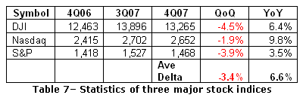

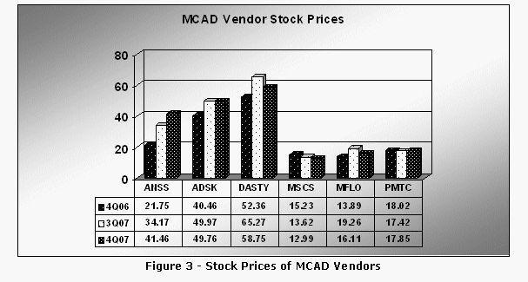
“Calendar Year” Performances
Where the fiscal year of a firm (ESI Group, Moldflow, PTC) does not correspond to the calendar year, the last four quarters of reported operations are used in this MCAD Commentary.
As Table 8 reveals, the combined 2007 year’s revenue for the group was $5.6 billion, up a very healthy 16% from the $4.8 billion in calendar year 2006. ANSYS was by far the percentage revenue gain leader at 46%. Autodesk, Dassault Systemes and ESI Group delivered close to 20% increases in annual revenue in US dollars. Both Moldflow and MSC.Software endured lower annual revenues than the year before.
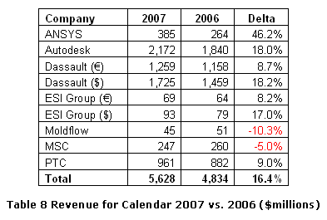
The combined earnings of the group were $818 million in 2007, up a noteworthy 33% from the $614 million in the prior year. See Table 9. Both Moldflow and MSC.Software suffered net losses for the year after having net gains in the prior year. The other firms delivered net earnings gains for 2007 over 2006.
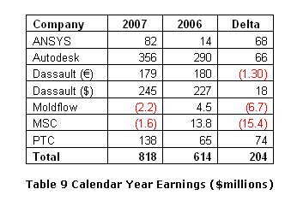
Annual Results by Company
For the calendar year ANSYS amassed total revenue of $385 million, a remarkable 46% increase over the $260 million in 2006. Software license revenue of $253 million, accounting for 66% of total revenue, was up 61%. Maintenance and services revenue of $132 million, accounting for 34% of total revenue, was increased 24% from the prior year. Note that the Fluent acquisition occurred early in 2006, so only 8 months of Fluent operations are included in 2006 results.
For calendar 2007, Autodesk revenue was a record $2.172 billion, an increase of 18% compared to 2007. Calendar 2008 net income was $356 million, a 23% increase compared to net income in 2007 of $290 million.
For the calendar year 2007 Dassault Systemes sported total revenue of $1.725 billion, an increase of 18.7% from the $1.46 billion in 2006. Software revenue was $1.46 billion, or 85% of total revenue. This was a 10.4% increase from the prior year. Services revenue was $268 million, up 15.5%.
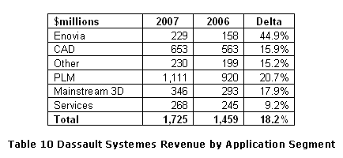
For calendar 2007 Moldflow had total revenue of $45 million, a decrease of 10% from the $50.7 million in calendar 2006. Net loss for the year was $2.2 million compared to a net gain of $4.5 million in the prior year.
For the calendar year 2007 MSC.Software delivered revenue of only $247 million, down 5% from the $259 million in 2006. Software revenue was $94.7 million, or 38% of total revenue, down 15% from the prior year. Maintenance revenue was $125.5 million, or 51% of total revenue, up 9%. (Usually a problem exists when a software vendor’s revenue from Software is lower than revenue from Maintenance). Services revenue was $26.4 million, or 11% of total revenue, down nearly 21% year-over-year.
North America accounted for 30.5% of total revenue, EMEA 38.9%, and Asia Pacific for 30.6%. American revenue was down half a percent, EMEA revenue was down 7.3%, and AP revenue was down 6.2%.
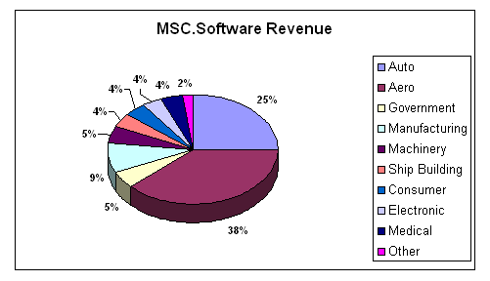
Net MSC loss for the 2007 year was $1.6 million, compared to a net gain of $13.8 million in the prior year. In the year, there were restructuring charges of $8.5 million and non-cash impairment charges of $4.8 million. There were no restructuring charges in 2006 and only $141K in impairment charges.
For the 2007 calendar year, PTC had total revenue of $961 million, an increase of 9% from the $882 million in the prior year. Net income for the year was $138 million, a 114% increase from the $65 million in 2006.
Forecast Guidance from Individual MCAD Providers
Several of the G7 firms did not provide forecast guidance. The firms that did provide forecasts predicted an average of year-over-year revenue increase of over 14%. Only Moldflow projected an annual growth rate of under 10%. On a sequential basis ANSYS, Autodesk and Dassault are forecasting a drop in Q1 2008 from the fourth quarter 2007, while PTC and Moldflow foresee an increase relative to the quarter just reported.
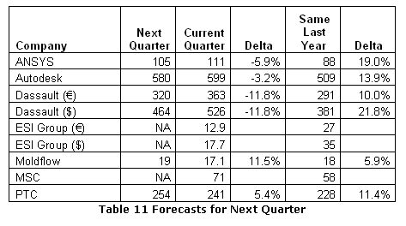
Individual Company Guidance
As guidance ANSYS expects revenue in the next quarter to be in the range of $103 million to $106 million, compared to $111 million in the quarter just reported and compared to $88 million in the same quarter a year earlier. For fiscal 2008 ANSYS expects revenue in the range of $442 to $447 million. This compares to $385 in fiscal 2007.
As guidance Autodesk expects net revenue for the first quarter to be in the range of $575 million and $585 million, versus $599 million in the quarter just reported and versus $508 million in the same quarter a year ago. However, the company is lowering its previous estimate of earnings per diluted share. Net revenue for the second quarter is expected to be about $590 million. For next year, Autodesk is maintaining its previously provided revenue guidance range of $2.425 billion and $2.475 billion. However, the company is lowering its previous estimate of earnings per diluted share.
As guidance Dassault Systemes said, “With the advancement of major strategic initiatives and the visibility we have going into 2008 we have confidence in our prospects, including our objectives for software revenue growth of about 12 percent in constant currencies and for about 10 percent revenue growth, also in constant currencies.”
ESI Group did not provide guidance.
As guidance Moldflow expects revenue for full fiscal 2008 year to grow in the range of 10% to 13% when compared to fiscal 2007.
MSC.Software said that it will not issue guidance at this time. The Company will continue to evaluate its decision to provide guidance in the future.
PTC's outlook for the second quarter, ending March 29, is for GAAP revenue to be between $248 million and $258 million, and GAAP earnings per share to be between $0.10 and $0.14. The revenue compares to $241 million in the quarter just reported and to $248 million in the corresponding quarter a year ago.
MCADCafè.com currently tracks the financial performance of multiple public companies in the Mechanical CAD market. Eight (8) companies were chosen for the author's May 8, 2003 Commentary #1. Four of these companies (Autodesk, Dassault Systemes, PTC and EDS PLM Solutions (now named UGS, a privately-held company) represented approximately 85 percent of the total revenue in this grouping, and each of these four companies offers a wide array of software and services products across the entire design to manufacturing space. The remaining four public companies (ANSYS, Moldflow, MSC.Software and Tecnomatix) offered specialized software/services products in specific MCAD niches and together they created the remaining 15 percent of the total group-of-8's revenue. Indeed, these latter four companies frequently partnered with the initial four to provide end-customers with broader solution suites.
For the author's August 2003 Commentary in MCADCafé.com, a ninth company, the ESI Group, was added. All nine were studied thereafter for comparison purposes. Tecnomatix has since been acquired by UGS and hence has been removed from this report. As a result of the acquisition of UGS by Siemens, UGS will not longer provide any separate financial data and therefore has also been dropped from the list.
The combined worldwide total annual revenue of these companies is nearly $6 billion, not an insignificant sum. But it is, in fact, less than 3 percent of the money spent annually on all types of software (source IDC). So why study MCAD companies at all? The key to MCAD's importance lies in the leverage its users apply to create the everyday durable goods with which we are all familiar: automobiles, trucks, military gear & weapons, appliances, farm & construction equipment, aircraft & aerospace vehicles, etc. In short, MCAD is arguably responsible for enabling today's manufacturing industries, which are the centerpieces of creating real productivity and wealth in every modern economy.
Understanding the comparative MCAD revenue content of various vendors is not merely academic. For example, it helps observers better understand the likely future competitive MCAD strength of each vendor relative to its peers in such areas as amount of money available for R&D, for potential new acquisitions, for financial stability to weather economic cycles, and for other key business factors.
In comparing financial performances of the four largest MCAD companies tracked by MCADCafé.com, it's instructive to account for the actual MCAD content of each. For example, the revenues of Dassault and PTC can arguably be considered 100% MCAD in nature, whereas Autodesk's total revenue is only partially made up from its business in MCAD. Some Autodesk revenue (~15%) stems from a segment which provides systems and software for creating and animating imagery. Even in the remaining 85% of Autodesk's total revenue, derived from its Design Solutions Segment, is divided among solutions for Manufacturing, GIS, AEC, and the platform technology group. Only the solutions of the Manufacturing Group (Inventor, AutoCAD Mechanical, Mechanical Desktop, Streamline, Point A, etc.) might be thought of as "pure" MCAD revenue.

It should also be noted that the companies have different business models. IBM, both direct and through Business Partners, is the exclusive marketing and sales arm for Dassault Systems high end product lines: CATIA, Enovia and Delmia. The IBM channel also carries SmarTeam solutions in a non-exclusive basis. IBM records the end user revenue and pays DS a royalty of approximately 50%. DS has been taken over increasing responsibility for managing IBM Business Partners. DS subsidiary SolidWorks is sold through value added resellers. Autodesk sells its products overwhelmingly through valued added resellers. The other MCAD vendors sell mostly on a direct basis. Direct sales result in greater percentage of end user revenue recognition but also involve higher cost of sales and risk.

While now buried inside Siemens, UGS annual revenues are right there at similar levels as the world's other MCAD revenue leaders Autodesk, Dassault and PTC. For purposes of our discussion, we considered the revenues from the remaining public companies ( ANSYS, ESI Group, Moldflow , and MSC.Software ) to be 100% MCAD.

Comments? Feedback? Tell us what you think about this topic, or share any additional information you may have on the subject! Submit your comments to: Email Contact
About the Authors:
Since 1996, Dr. Russ Henke has been president of HENKE ASSOCIATES, a San Francisco Bay Area high-tech business & management consulting firm. The number of client companies for Henke Associates now numbers more than forty. During his corporate career, Henke operated sequentially on "both sides" of MCAD and EDA, as a user and as a vendor. He's a veteran corporate executive from Cincinnati Milacron, SDRC, Schlumberger Applicon, Gould Electronics, ATP, and Mentor Graphics. Henke is a Fellow of the Society of Manufacturing Engineers (SME) and served on the SME International Board of Directors. He is also a member of the IEEE and a Life Fellow of ASME International. In April 2006, Dr. Henke received the 2006 Lifetime Achievement Award from The CAD Society, presented by CAD Society president Jeff Rowe at COFES2006 in Scottsdale, AZ. In February 2007, Henke became affiliated with Cyon Research's select group of experts on business and technology issues as a Senior Analyst. This Cyon Research connection aids and supplements Henke's ongoing, independent consulting practice (Henke Associates).
An affiliate of the HENKE ASSOCIATES team since 2001, LA-based Dr. John R. (Jack) Horgan co-authored this March 2008 MCAD Industry Commentary. Dr. Horgan's prior corporate career has included executive positions at Applicon, Aries Technology, CADAM and MICROCADAM, as well as a stint at IBM. Dr. Horgan is also an editor of EDAcafe Weekly.
Since May 2003 the authors have now published a total of sixty-two (62) independent articles on MCAD, PLM, EDA and Electronics IP on IBSystems' MCADCafé and EDACafé. Further information on HENKE ASSOCIATES, and URL's for past Commentaries, are available at http://www.henkeassociates.net. March 31, 2008 marks the 12th Anniversary of HENKE ASSOCIATES' founding.


